**Course: Advance Bio Informatics**

**Module Title: Phases of Cell Cycle**

**Module No: 151**

**Cell Cycle: Key to** **Drug Discovery**

**Cell Cycle** is the series of actions that take place in a cell leading to its division and duplication that produces two daughter cells.

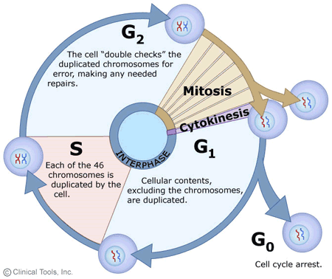

**Cell cycle phases**

* **G1 phase :** Cell increase in size, produce RNA and synthesize protein
* **S phase:** DNA and centrosomes are synthesize
* **G2 phase:** Cells grow and produce new protein that are needed for mitosis
* **M phase:** Cell growth and protein production stop, each cell undergoes a complex and divided into two daughter cells

**Cell Cycle stages**

